**Working with Docker Volumes**

Docker Volume is a mechanism in Docker that allows you to persist data even after a container is deleted or recreated. It provides a way to store data outside of the container's filesystem, so that data is not lost when the container is restarted or deleted.

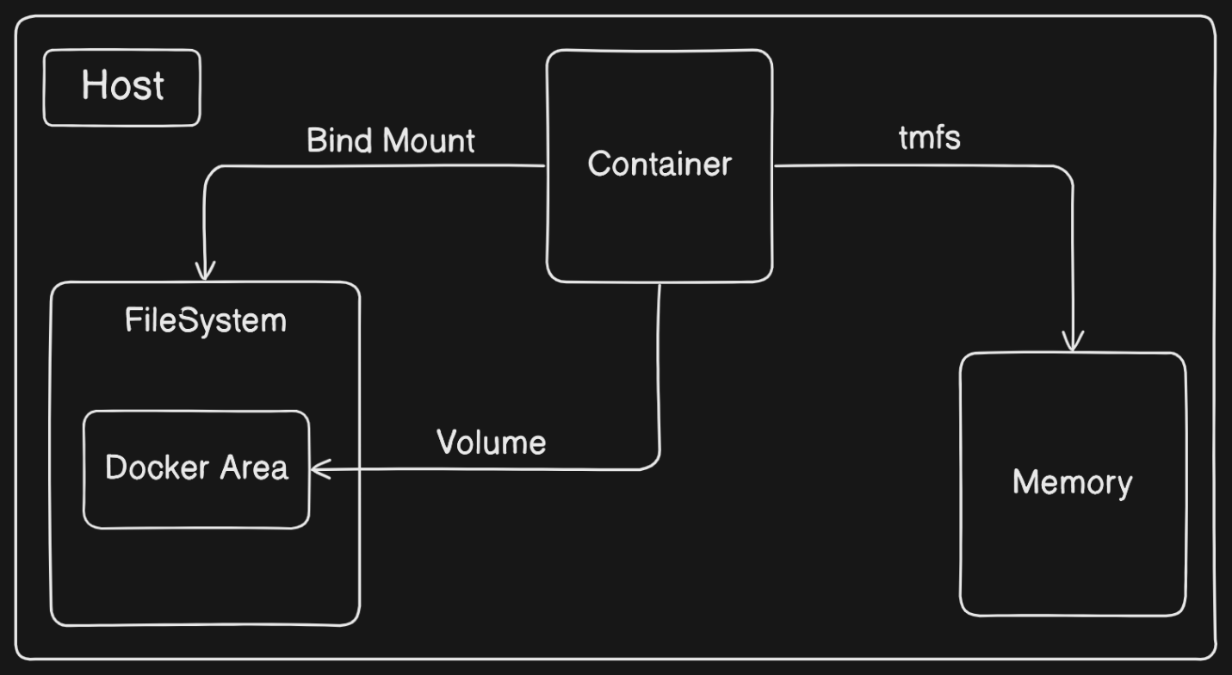

**Why do we need Docker Volumes?**

When you run a container, it has its own filesystem, which is ephemeral. This means that any data written to the container's filesystem will be lost when the container is deleted or restarted. Docker Volumes provide a way to decouple the data from the container's filesystem, so that data can be preserved even when the container is recreated.

**How do Docker Volumes work?**

A Docker Volume is a directory that is **shared** between the host machine and a container. When you create a volume, Docker creates a directory on the host machine, and mounts it to a directory inside the container. This allows data to be written to the volume, which is persisted even when the container is deleted or recreated.

**Example Scenerio: Using Docker volumes with a NoSQL Database (Apache Cassandra)**

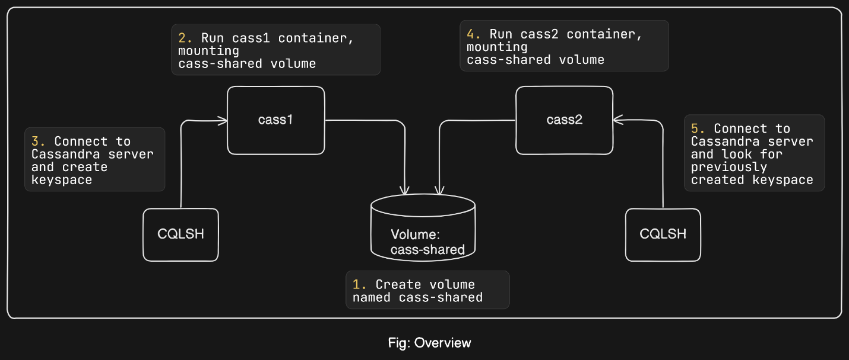In this scenario, we will use Docker to create and manage a single-node Cassandra cluster. We'll create a keyspace, delete the container, and then recover the keyspace on a new node in another container using Docker volumes. Follow the detailed steps below:

**Step 1: Create Docker Volume**

First, we will create a Docker volume that will store the Cassandra database files. This volume will use disk space on the local machine.

docker volume create \

--driver local \

--label example=cassandra \

cass-shared

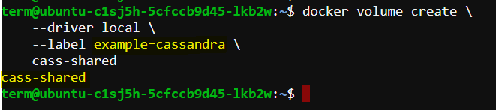

**Explanation:**

* **docker volume create:** Command to create a Docker volume.
* **--driver local:** Specifies that the volume should use the local driver.
* **--label example=cassandra:** Adds a label to the volume for easier management and identification.
* **cass-shared:** The name of the volume.

**Step 2: Run a Cassandra Container**

Next, run a Cassandra container and mount the previously created volume to the container.

docker run -d \

--volume cass-shared:/var/lib/cassandra/data \

--name cass1 \

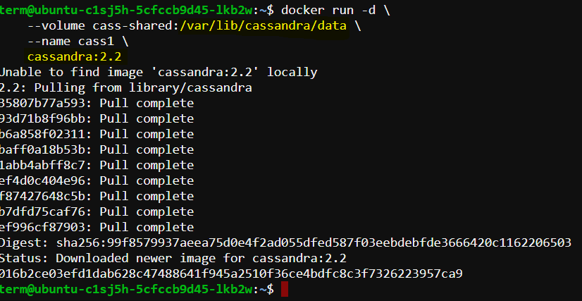 cassandra:2.2

**Explanation:**

* **ocker run -d:** Runs the container in detached mode.
* **--volume cass-shared:/var/lib/cassandra/data:** Mounts the cass-shared volume to /var/lib/cassandra/data inside the container.
* **--name cass1:** Names the container cass1.
* **cassandra:2.2:** Uses the Cassandra image version 2.2 from Docker Hub.

**Step 3: Connect to the Cassandra Container**

Use the Cassandra client tool (CQLSH) to connect to the running Cassandra server.

docker run -it --rm \

--link cass1:cass \

cassandra:2.2 \

cqlsh cass

**Explanation:**

* **docker run -it --rm:** Runs the container interactively and removes it after exit.
* **--link cass1:cass:** Links the client container to the cass1 container.
* **cassandra:2.2:** Uses the Cassandra image version 2.2.
* **cqlsh cass:** Runs the CQLSH command line tool to connect to the Cassandra server.

Now you can inspect or modify your Cassandra database from the CQLSH command line. First, look for a keyspace named docker_hello_world:

select *

from system.schema_keyspaces

where keyspace_name = 'docker_hello_world';

**Explanation:**

* **select * from system.schema_keyspaces where keyspace_name = 'docker_hello_world';:** Queries the system schema for the docker_hello_world keyspace.

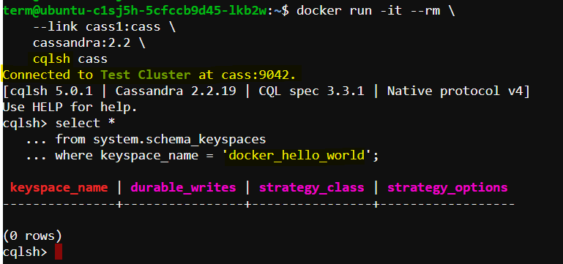

Cassandra should return an *empty* list. This means the database hasn’t been *modified* by the example.

**Step 04: Create and Verify a Keyspace**

**Inside the CQLSH shell, create a keyspace named docker_hello_world.**

create keyspace docker_hello_world

with replication = {

'class' : 'SimpleStrategy',

'replication_factor': 1

};

**Explanation:**

* **create keyspace:** Creates a new keyspace.
* **docker_hello_world**: The name of the keyspace.
* **with replication = { 'class' : 'SimpleStrategy', 'replication_factor': 1 }:** Specifies the replication strategy and factor.

**Verify the keyspace creation:**

**select \***

**from system.schema_keyspaces**

**where keyspace_name = 'docker_hello_world';**

If the keyspace was created successfully, you will see the entry in the query result.

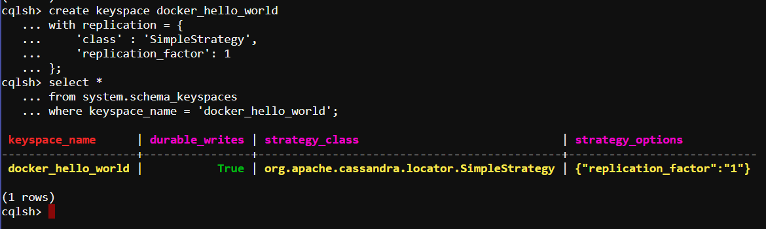

**Step 5: Stop and Remove the Cassandra Container**

**Exit the CQLSH shell and remove the Cassandra container.**

Quit

docker stop cass1

docker rm -vf cass1

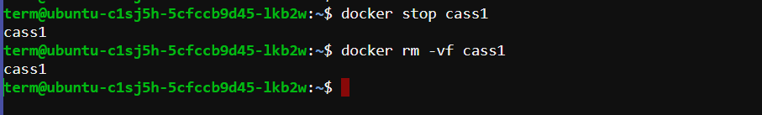

**Explanation:**

* **quit**: Exits the CQLSH shell.
* **docker stop cass1**: Stops the cass1 container.
* **docker rm -vf cass1**: Removes the cass1 container forcefully and deletes associated resources.

**Step 6: Test Data Recovery**

Create a new Cassandra container and attach the volume to it.

docker run -d \

--volume cass-shared:/var/lib/cassandra/data \

--name cass2 \

cassandra:2.2

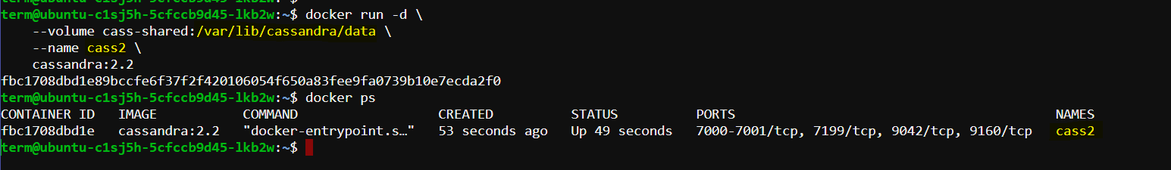

**Connect to the new Cassandra container using CQLSH.**

docker run -it --rm \

--link cass2:cass \

cassandra:2.2 \

cqlsh cass

**Query the keyspace to verify data persistence.**

select *

from system.schema_keyspaces

where keyspace_name = 'docker_hello_world';

If the keyspace docker_hello_world is listed in the result, it confirms that the data persisted in the cass-shared volume

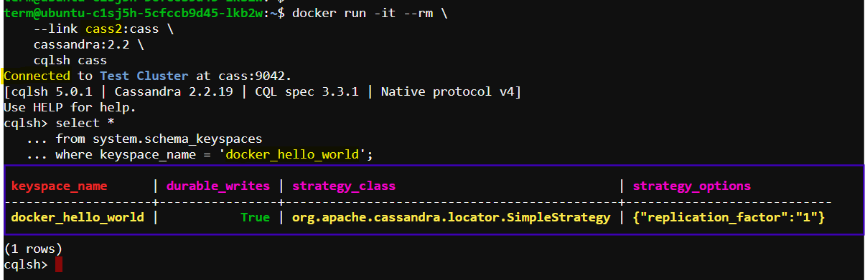

**Step 7: Clean Up**

**Exit the CQLSH shell and remove the containers and volume.**

quit

docker rm -vf cass2

docker volume rm cass-shared

**Explanation:**

* **quit**: Exits the CQLSH shell.
* **docker rm -vf cass2**: Removes the cass2 container forcefully.
* **docker volume rm cass-shared**: Deletes the cass-shared volume.

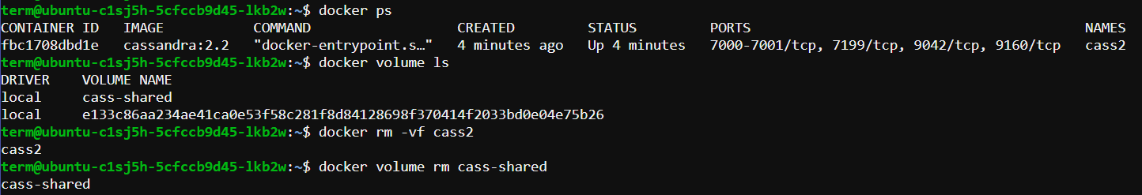

**Summary**

**In this scenario, we have:**

* Created a Docker volume.
* Ran a Cassandra container with the volume mounted.
* Connected to the Cassandra container using CQLSH.
* Created and verified a keyspace.
* Stopped and removed the Cassandra container.
* Tested data recovery by creating a new container and verifying the keyspace.
* Cleaned up by removing the containers and volume.

This demonstrates how to use Docker volumes for data persistence in a Cassandra database, ensuring that data remains available even after the container is deleted.